**INDEX**

Chapter 01. Introduction …………………………………………………….. 02

Chapter 02. Objective …………………………………………………..…….. 05

Chapter 03. Design & Implementation ……………….……………..… 08

Chapter 04. Code ……………………………………………………………..…. 12

Chapter 05. Result ………………………………………………………….…… 20

Chapter 06. Conclusion ……………………………………………………..… 23

**Introduction**



CALENDAR PROJECT

BANGLADESH UNIVERSITY OF BUSINESS AND TECHNOLOGY



MAKINTOS

***A*** calendar is a system of organizing days for social, religious, commercial or administrative purposes. This is done by giving names to periods of time, typically days, weeks, months and years. A date is the designation of a single, specific day within such a system. A calendar is also a physical record (often paper) of such a system. A calendar can also mean a list of planned events, such as a court calendar or a partly or fully chronological list of documents, such as a calendar of wills. Periods in a calendar (such as years and months) are usually, though not necessarily, synchronized with the cycle of the sun or the moon.

The most common type of pre-modern calendar was the lunisolar calendar, a lunar calendar that occasionally adds one intercalary month to remain synchronized with the solar year over the long term.

The term *calendar* is taken from calendar, the term for the first day of the month in the Roman calendar, related to the verb Calare "to call out", referring to the "calling" of the new moon when it was first seen. Latin caldarium meant "account book, register" (as accounts were settled and debts were collected on the calends of each month). The Latin term was adopted in Old French as calendar and from there in Middle English as calendar by the 13th century (the spelling *calendar* is early modern).

The course of the Sun and the Moon are the most evident forms of timekeeping, and the year and lunation were most commonly used in pre-modern societies worldwide as time units. Nevertheless, the Roman calendar contained very ancient remnants of a pre-Etruscan 10-month solar year. The first recorded calendars date to the Bronze Age, dependent on the development of writing in the Ancient Near East, the Egyptian and Sumerian calendars.

A large number of calendar systems which were based on the Babylonian calendar, and which were found in the Ancient Near East, date from the Iron Age. Amongst such calendar systems was the calendar system of the Persian Empire, which in turn gave rise to the Zoroastrian as well as the Hebrew calendar.

A great number of Hellenic calendars developed in Classical Greece, and with the Hellenistic period also influenced calendars outside of the immediate sphere of Greek influence, giving rise to the various Hindu calendars as well as to the ancient Roman calendar.

Calendars in antiquity were lunisolar, depending on the introduction of intercalary months to align the solar and the lunar years. This was mostly based on observation, but there may have been early attempts to model the pattern of intercalation algorithmically, as evidenced in the fragmentary 2nd-century Coligny calendar.

The Roman calendar was reformed by Julius Caesar in 45 BC. The Julian calendar was no longer dependent on the observation of the new moon but simply followed an algorithm of introducing a leap day every four years. This created a dissociation of the calendar month from the lunation.

The Islamic calendar is based on the prohibition of intercalation by Muhammad, in Islamic tradition dated to a sermon held on 9 Dhu al-Hijjah AH 10 (Julian date: 6 March 632). This resulted in an observation-based lunar calendar that shifts relative to the seasons of the solar year.



**Objective**

* Search in any year.
* Important day search.
* Save any memorable days.

The primary practical use of a calendar is to identify days: to be informed about or to agree on a future event and to record an event that has happened. Days may be significant for agricultural, civil, religious or social reasons. For example, a calendar provides a way to determine when to start planting or harvesting, which days are [religious](https://en.wikipedia.org/wiki/Religious_holiday) or [civil holidays](https://en.wikipedia.org/wiki/Civil_holiday), which days mark the beginning and end of business accounting periods, and which days have legal significance, such as the day taxes are due or a contract expires. Also a calendar may, by identifying a day, provide other useful information about the day such as its season.

Calendars are also used to help people manage their personal schedules, time and activities, particularly when individuals have numerous work, school, and family commitments. People frequently use multiple systems, and may keep both a [business](https://en.wikipedia.org/wiki/Business) and [family](https://en.wikipedia.org/wiki/Family) calendar to help prevent them from overcommitting their time.

Calendars are also used as part of a complete [timekeeping](https://en.wikipedia.org/wiki/Timekeeping) system: date and time of day together specify a moment in [time](https://en.wikipedia.org/wiki/Time). In the modern world, timekeepers can show time, date and weekday.

* Let’s you see all your events at a quick glance.
* Makes it easy to schedule new events. You know what’s already there.
* Helps with scheduling blog posts and hosting guests. Useful to know when to send out questions, request them, or setup a reminder to answer and email them back.
* Helps with setting writing deadlines.

Calendars play an important role in our day to day life. They help us plan our routine, celebrate special days, remember important dates and organize major events. Life would not have been the same if it weren’t for these systems. Different communities and countries follow different calendars, each having their own set of holidays. In this article, some of the major calendars used in India have been discussed, as well as how they differ in their perception of days, weeks, months and seasons.

Calendars are a means by which days of the week and months of the year are organized for various purposes. The word itself is acquired from the Latin calendar, which represented the first day of the month. While we most commonly refer to calendars for the upcoming weeks or months or even years, the calendars we follow usually represent the entire system (how the days, weeks and years are set according to a standard). The regional holidays, for instance, differ greatly as we move around the world. Some calendars follow the method of counting days from a set date; any calculations regarding the days, therefore, requires simple adding and subtracting.   
  
These organized systems often take the form of paper and computer or mobile applications. The calendars available on computers and other devices have the added advantage of being set up to remind the person of a particular event or day. Calendars around the world have been influenced by the solar and lunar cycles or based on earlier systems. Either way, life follows a set and organized routine with the help of calendars.



**Design & Implementation**

The key features of this calendar project are:

* Windows properties have been used to make the overall colorful and handling has been used in this project.
* It provides a very simple interface and displays days, dates, months and years based on the input given by the user.

The first calendar reform of the early modern era was the Gregorian calendar, introduced in 1582 based on the observation of a long-term shift between the Julian calendar and the solar year.

There have been a number of modern proposals for reform of the calendar, such as the World Calendar, International Fixed Calendar, Holocene calendar, and, recently, the Hanky-Henry Permanent Calendar. Such ideas are mooted from time to time but have failed to gain traction because of the loss of continuity, massive upheaval in implementation, and religious objections.

A full calendar system has a different calendar date for every day. Thus the week cycle is by itself not a full calendar system; neither is a system to name the days within a year without a system for identifying the years.

The simplest calendar system just counts time periods from a reference date. This applies for the Julian day or Unix Time. Virtually the only possible variation is using a different reference date, in particular, one less distant in the past to make the numbers smaller. Computations in these systems are just a matter of addition and subtraction.

Other calendars have one (or multiple) larger units of time.

Calendars that contain one level of cycles:

* week and weekday – this system (without year, the week number keeps on increasing) is not very common
* year and ordinal date within the year, e.g., the ISO 8601 ordinal date system.

Calendars with two levels of cycles:

* year, month, and day – most systems, including the Gregorian calendar (and its very similar predecessor, the Julian calendar), the Islamic calendar, the Solar Hijri calendar and the Hebrew calendar
* year, week, and weekday – e.g., the ISO week date

Cycles can be synchronized with periodic phenomena:

[](https://en.wikipedia.org/wiki/File:Sun_and_Moon_Nuremberg_chronicle.jpg)

* Lunar calendars are synchronized to the motion of the Moon (lunar phases); an example is the Islamic calendar.
* Solar calendars are based on perceived seasonal changes synchronized to the apparent motion of the Sun; an example is the Persian calendar.
* Lunisolar calendars are based on a combination of both solar and lunar reckonings; examples include the traditional calendar of China, the Hindu calendar in India, and the Hebrew calendar.
* The week cycle is an example of one that is not synchronized to any external phenomenon (although it may have been derived from lunar phases, beginning anew every month).

Very commonly a calendar includes more than one type of cycle, or has both cyclic and non-cyclic elements.

Most calendars incorporate more complex cycles. For example, the vast majority of them track years, months, weeks and days. The seven-day week is practically universal, though its use varies. It has run uninterrupted for millennia.



**Code**

#include<stdio.h>

#define TRUE 1

#define FALSE 0

int days_in_month[]={0,31,28,31,30,31,30,31,31,30,31,30,31};

char *months[]=

{

" ",

"\n\n\nJanuary",

"\n\n\nFebruary",

"\n\n\nMarch",

"\n\n\nApril",

"\n\n\nMay",

"\n\n\nJune",

"\n\n\nJuly",

"\n\n\nAugust",

"\n\n\nSeptember",

"\n\n\nOctober",

"\n\n\nNovember",

"\n\n\nDecember"

};

int inputyear(void)

{

int year;

printf("Please Enter a Year (Example:1998):");

scanf("%d", &year);

return year;

}

int determinedaycode(int year)

{

int daycode;

int d1, d2, d3;

d1 = (year - 1.)/ 4.0;

d2 = (year - 1.)/ 100.;

d3 = (year - 1.)/ 400.;

daycode = (year + d1 - d2 + d3) %7;

return daycode;

}

int determineleapyear(int year)

{

if(year% 4 == FALSE && year%100 != FALSE || year%400 == FALSE)

{

days_in_month[2] = 29;

return TRUE;

}

else

{

days_in_month[2] = 28;

return FALSE;

}

}

void calendar(int year, int daycode)

{

int month, day;

for ( month = 1; month <= 12; month++ )

{

printf("%s", months[month]);

printf("\n\nSun Mon Tue Wed Thu Fri Sat\n" );

for ( day = 1; day <= 1 + daycode * 5; day++ )

{

printf(" ");

}

for ( day = 1; day <= days_in_month[month]; day++ )

{

printf("%2d", day );

if ( ( day + daycode ) % 7 > 0 )

printf(" " );

else

printf("\n " );

}

daycode = ( daycode + days_in_month[month] ) % 7;

}

}

int main(void)

{

int year, daycode, leapyear;

year = inputyear();

daycode = determinedaycode(year);

determineleapyear(year);

calendar(year, daycode);

printf("\n");

printf("\n");

int date, month;

printf("Please Enter Your Remember Date (Example: dd mm):");

scanf("%d %d",&date,&month);

if((date<=10)&&(date>9)&&(month<=01))

{

printf("The return of Bangabandhu.");

}

else if((date<=19)&&(date>18)&&(month<=01))

{

printf("National Teacher Day.");

}

else if((date<=21)&&(date>20)&&(month<=02))

{

printf("International Mother Language Day.");

}

else if((date<=22)&&(date>21)&&(month<=02))

{

printf("World Thinking Day.");

}

else if((date<=25)&&(date>24)&&(month<=02))

{

printf("Pilkhana Killing Day.");

}

else if((date<=17)&&(date>16)&&(month<=03))

{

printf("National children Day.");

}

else if((date<=23)&&(date>22)&&(month<=03))

{

printf("National Flag Day.");

}

else if((date<=25)&&(date>24)&&(month<=03))

{

printf("The Black Night Day.");

}

else if((date<=26)&&(date>25)&&(month<=03))

{

printf("The Independence Day of Bangladesh");

}

else if((date<=7)&&(date>6)&&(month<=04))

{

printf("World Health Day");

}

else if((date<=23)&&(date>22)&&(month<=04))

{

printf("World Book Day");

}

else if((date<=16)&&(date>15)&&(month<=12))

{

printf("Victory day.");

}

else if((date<=25)&&(date>24)&&(month<=12))

{

printf("Christmas day.");

}

else if((date<=18)&&(date>17)&&(month<=12))

{

printf("Birthday of SAKHAWAT.\nMany Many Happy Returns of the Day.");

}

else if((date<=10)&&(date>9)&&(month<=10))

{

printf("Join a new job.");

}

else if((date<=19)&&(date>18)&&(month<=03))

{

printf("Start mid-term Examination.");

}

else

{

printf("Sorry, This days in not storage.");

}

}

**Result**

* At first, the user needs to provide year as input. Example: 2018. This displays the calendar for year 2018.
* The application displays day corresponding to a given date.
* It also displays day and dates corresponding to a particular month and year.

The simple input and output are:

Input: 10 / 01

Output: The return of Bangabandhu.

Input: 21 / 02

Output: International Mother Language Day.

Input: 26 / 03

Output: The Independence Day of Bangladesh.

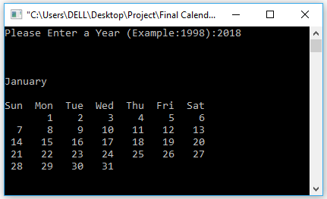

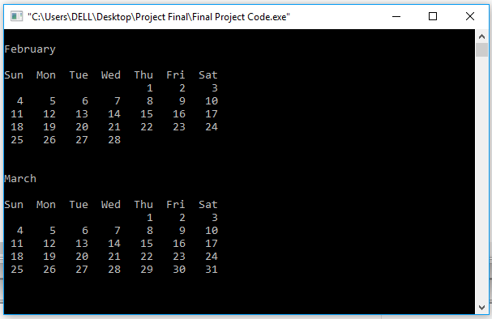

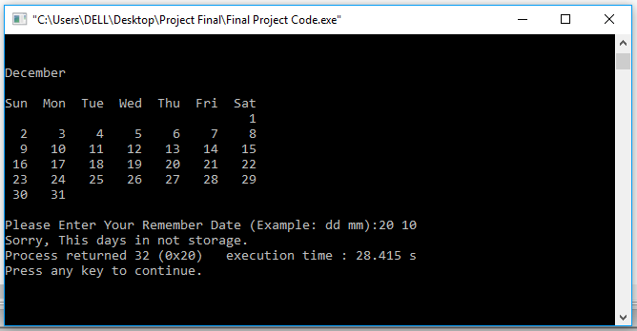

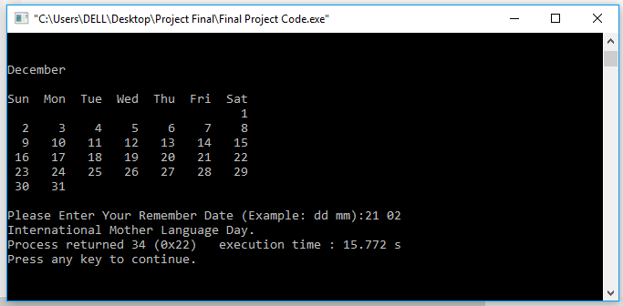

**Conclusion**

Finally, we can say that calendar is part and parcel of our life. Calendar makes it easy for businesses to stay connected anytime and anywhere. Once set up, users can access the calendar, schedule meetings, and share with anyone they choose. At last say that a calendar is most importance in our life.

The digital calendar has many advantages. We are virtually attached to our smart phones these days so we always have our calendar with us. Doctor appointment cards no longer get lost in our coat pockets because we can now enter the appointment straight into our favorite calendar app. We can schedule recurring events such as kids’ sports practices or work meetings. We can add Facebook, Event rite or Evite events directly to our calendars without having to type in the details. Digital calendars allow us to share calendars with spouses, helping everyone keep track of all the various places the kids need to be each week. Cloud backup for calendars keeps us from losing valuable information. Finally, digital calendars come in so many varieties, we can really choose which tool helps us be the most productive.